SAVEETHA SCHOOL OF ENGINEERING
SAVEETHA INSTITUTE OF MEDICAL AND TECHNICAL SCIENCES
INSTITUTE OF CSE
CSA15- CLOUD COMPUTING AND BIG DATA ANALYTICS
LIST OF EXPERIMENTS

2. Create a simple cloud software application for Property Buying &amp; Rental process (In
Chennai city) using any Cloud Service Provider to demonstrate SaaS include the
necessary fields such as Buy, Rent, commercial, Rental Agreement Rental
Agreement, Area, place, Range, property value etc.
INPUT:
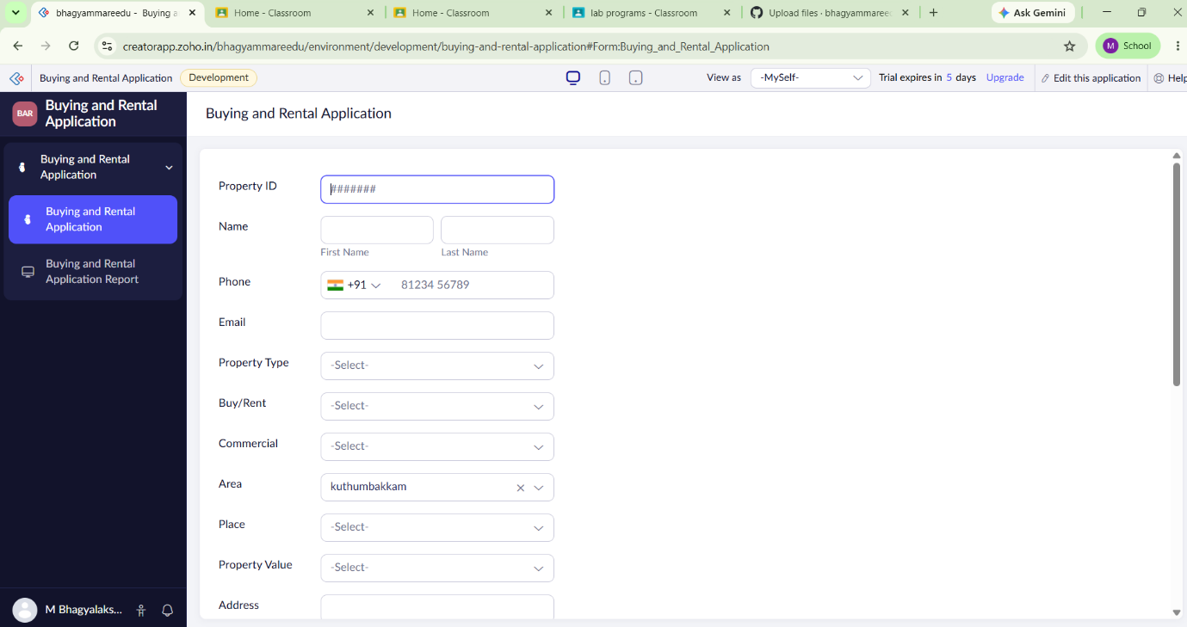

OVERVIEW:
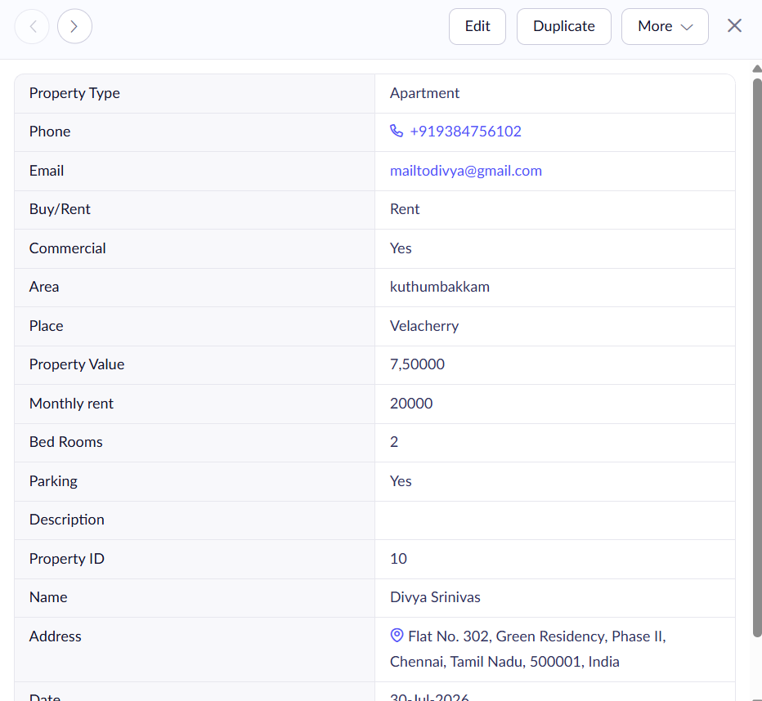

OUTPUT:
